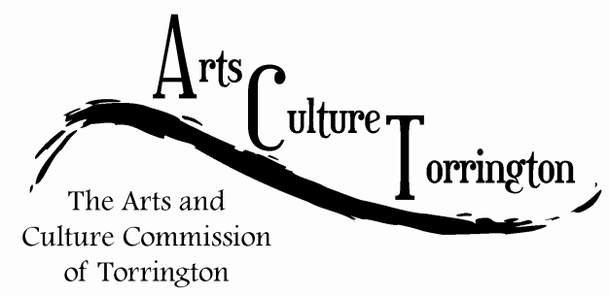

AGENDA

December 3, 2014**|** 10:00am – 11am **|** City Hall Auditorium

1. Call To Order
2. Main Street Marketplace: Select an organization/body to take over the event for 2015.
3. Adjournment